Tatton Wildlife Newsletter – Autumn
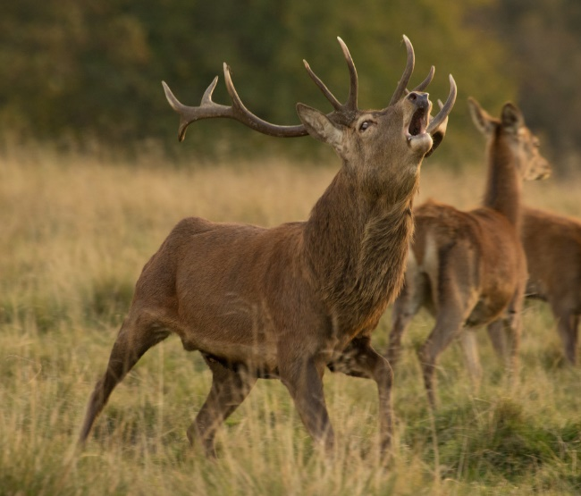
This is a fantastic season to discover the vast array of wildlife that Tatton can offer and to witness one of the most fascinating aspects of animal behaviour. It is a great time to get out and explore the park and to reap the benefits that a connection with nature can give to us all.
Deer
The decreasing daylight hours trigger the increase of testosterone in the male deer. This is the start of the rut.
Firstly, the males separate from each other and begin to create shallow scrapes using their front hooves and antlers. They will fill with muddy water with which they cover their coats as they wallow. They often urinate in the wallow to add to the pungent aroma that they naturally have at this time of year. They can be seen pawing the ground aggressively and may even adorn their antlers with grass. All of this is to make themselves look more intimidating. They will begin to call. The red deer have a deep, far-carrying bellow while the fallow deer have a snorting, rasping belch! The fallow deer may ‘parallel walk’ – this is where two males walk alongside each other weighing each other up. If they are similarly matched, they may begin to fight. If all these tactics still do not deter opposition males, then a fight may begin. This is the last resort, as avoiding injury at this time of year is important also. The antlers lock together in what is basically a show of strength as they push each other to determine which is the stronger animal.
They are fighting for the opportunity to mate, to make sure that the stronger genes are the ones passed down to the next generation. Red deer will try to keep as many hinds together in a group as possible, defending them against other males. The fallow deer hold a territory, often a raised area, in which they will call and try to attract the does to them.
It is important that the deer are given plenty of space and are left to their natural behaviour. Any disturbance during the rut causes unnecessary stress and has an impact on the herd’s breeding success. If the females are late to conceive, they give birth to calves later next year which in turn means they have less time to put condition on for the preparation of winter next year.
Tree safety management and habitat conservation
Tatton covers over 800 hectares of land which includes many thousands of trees. These are highly valued for their natural beauty, the wildlife they support, and their importance in the landscape. The most important trees tend to be those of greatest size and age.
There is a need to inspect trees in and near public places and adjacent to buildings and working areas, to assess possible risk to people, and to take remedial action as deemed appropriate. The remedial work is undertaken to maintain valuable habitat where possible – e.g., retaining cavities, decay, and dead wood to support invertebrate populations, fungi and nesting sites for bats and birds. However, where the risk is not acceptable, trees are felled (or monolithed if possible, to retain the main standing stem but reduce the risk).
Except for essential safety work, tree work operations are suspended through the nesting season to prevent disruption to breeding birds. Most of the remedial work is undertaken during the late autumn and winter: pruning during winter months allows for the healing to begin before the warmer weather brings possible complications (including destructive insects and fungal infections), giving the tree a much better chance of making an uninhibited recovery.
Fungi
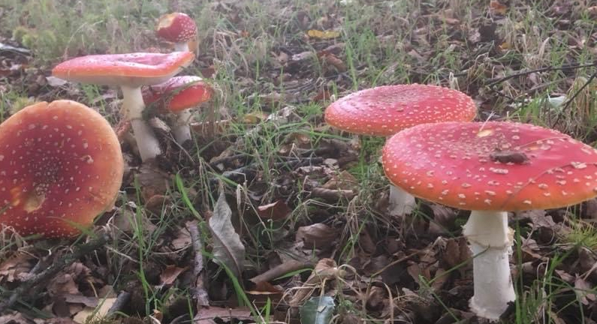
Autumn is also the best season to look for the wide variety of fungi species that can be found at Tatton. Our policy of leaving dead wood wherever possible is beneficial to them. One of the most striking is the fly agaric (pictured below) which can often be found under birch trees.
We have a fungal foray with Fungal Punk Dave on Sunday 17th October, this is a great opportunity to learn more about the mysterious and fascinating species that we have here. Booking is essential at https://www.tattonpark.org.uk/home.aspx

Compiled by Tatton’s Ranger Team

