Tatton Wildlife Newsletter – Spring
Spring is a season of change and new beginnings. The dark days of winter are behind us and the longer, warmer days, the fresh new foliage and the sound of birdsong are a tonic to lift the spirits. This connection with nature is proven to benefit wellbeing and Tatton is a valuable resource in this regard. Spring is a fantastic time to get out there and enjoy nature and all that Tatton has to offer.

Birds
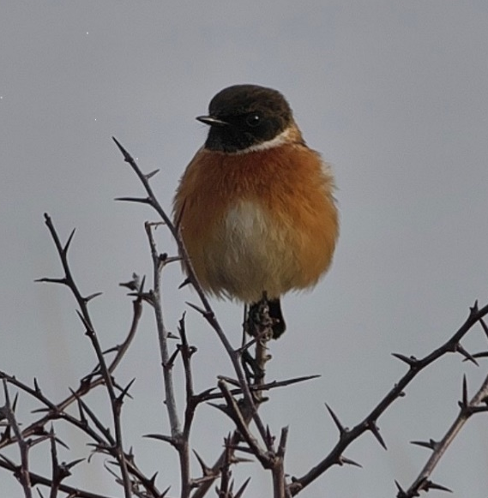
Probably the most anticipated time for any birdwatcher, spring is a fascinating season. Whether it be migrant summer birds arriving in pristine breeding plumage or the chance to brush up on those bird calls. It is also when more unusual birds are found as everything is on the move.
Long anticipated migrants will arrive. The sand martin is usually first back and can be seen in flight, feeding up on freshly hatched insects over Tatton Mere after their arduous journey from Africa. They are closely followed by members of the warbler family, the chiffchaff and willow warbler, two species hard to identify but easily separated by their calls. Swallows and house martins will follow and then later, the swift. We will also get passage birds such as wheatears and terns. Now is also the time to look for a hobby or even a passing osprey.
Birdsong is now at its peak too as rival males proclaim ownership of territory or try to attract a mate. Early morning is always the best time to listen in and our woodlands such as Dairy Wood Way, Sandpit Wood or Dog Wood are good places to try.
Stonechats which spent the winter here will now depart. One of our local birders, Tony Usher, captured the photograph above of a splendid male stonechat while he was out in the park. Six whooper swans on Tatton Mere was an unusual sighting in December. Also a rare firecrest was found by one of our rangers in Dog Wood in February.
Deer
The daily deer feeding which has helped them maintain condition will cease once the grass begins to grow again. They will now moult into their brighter summer coats. The red deer change to a deeper russet coloration while the fallow develop a much lighter, spotted coat. Freshly cast antlers will regrow immediately and the deer are now known to be ‘in velvet’. They are soft to the touch and any damage to them at this stage will cause deformity later.
Woodland Management
Visitors to Millennium Wood may have noticed a stand of hazel close to the gate. This is being managed as a small coppice on a rotation of 5/6 years. Coppicing is the earliest known form of woodland management and is a method of cutting broadleaved trees down to the ground at regular intervals (anything from 5 to 25 years, depending on the species). A cluster of new shoots sprout up from the stump (stool) and these eventually provide new, manageable straight poles. These poles are used within Tatton as hedging stakes, bean and pea sticks.
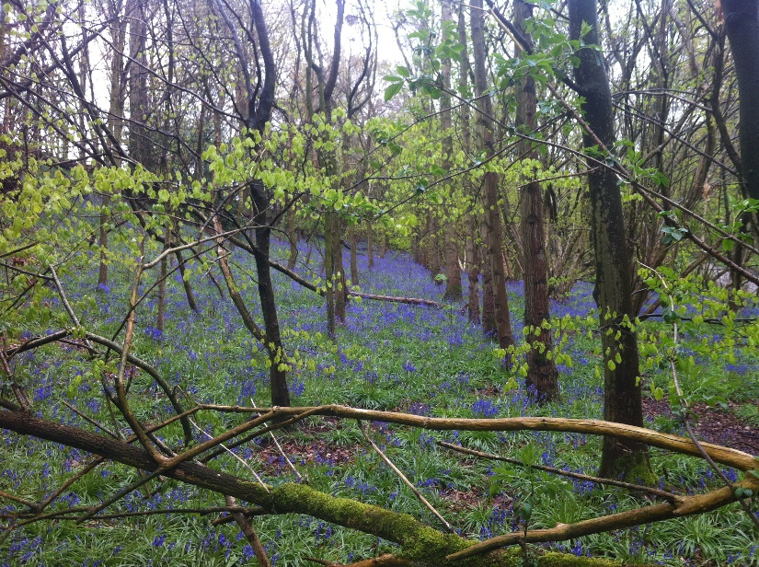
Coppicing also allows light to reach the woodland floor which benefits wildflowers such as the bluebell, as shown in this picture taken in Dog Wood. This in turn increases the diversity of the habitat.
The work has been undertaken by our volunteers who carefully cut, sort and stack the poles but also build woven barriers around the stools (using hazel stakes and brash) to deter the rabbits nibbling the new shoots.
The hazel is easily recognizable – in early spring the male catkins (‘lamb’s tails’) dangle from leafless twigs and release clouds of golden pollen. The hazelnuts, which are pale green in summer but a warm brown by autumn, are popular as a food source for many birds and small mammals.
Compiled by Tatton’s Ranger Team

