Tatton Wildlife Newsletter – Summer
The parkland during summer is arguably at its most beautiful. With so much to see and explore, it provides the perfect backdrop to a relaxing walk or picnic. It is also a great time to see the many and varied forms of wildlife that Tatton Park provides a home for. The longer, warmer days of summer, with plentiful food available and more time to feed, give our wildlife a better chance to raise their young successfully. Plants and trees have the best conditions to grow, pollinate and cast their seed.
Getting out and engaging with nature has proven to benefit our mental health. More than ever before, the value of outdoor spaces like Tatton cannot be understated.
Birds
Spring saw the return of our summer migrants and our earliest ever returning sand martin was recorded on 2nd March. The next to appear was predictably, a chiffchaff on the 17th. These were followed by an unprecedented number of sand martins, swallows, house martins and swifts. Summer arrivals, passing through, occurred too in the form of common sandpipers and several wheatears, one of which is pictured, photographed by a member of staff.
We also had some interesting sightings in spring. A male common scoter on Tatton Mere on 17th March was followed the day after by a black-necked grebe. The most unusual was a Lady Amherst’s pheasant, this species is kept in ornamental collections and was released on some shooting estates. It does not have a sustainable wild population in the U.K. so we can only assume it had escaped from a collection.
Summer is a great time to spot terns over the mere including the rarer black tern. Now is also a good time to see the hobby, this uncommon, diminutive falcon is a summer visitor, it may be seen hunting dragonflies or even swallows over the meres.

Deer
Summer is calving time. If you see a female deer well away from the rest of the herd it probably has a calf or fawn nearby or is about to give birth. The females choose an isolated clump of vegetation or an area of fallen branches to “drop” their young and hide it from any potential predator. The calf or fawn has no scent, again preventing detection from predators. It will lie still during the day and the mother will return at night to feed it. Therefore, it is so important that they are left alone as any scent left by humans may result in the mother abandoning it. After a couple of days, they will be up on their feet and following the mother. It is also very important that dogs are kept under close control to avoid any disturbance to the new-born calves and fawns.
The male deer will now stay in bachelor groups, their antlers are “in-velvet” and growing. They spend the summer grazing and getting into top condition in preparation for the rut later in the year.
Insects and Surveys
Our survey work was disrupted last year but we are hoping for a better season in 2021. We have already started the annual butterfly transect, and a dry April coupled with a wet May has resulted in low counts with only peacock and small tortoiseshell seen in any numbers. This picture of a peacock was captured by one of our rangers.
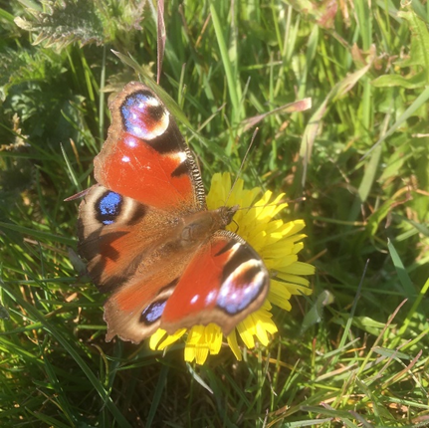
Annual bat surveys have been conducted here at Tatton by South Lancashire Bat Group since 2014 and we are hoping that they will resume this year.
This year a new Diptera (flies!) survey will be undertaken by staff from Liverpool Museum. If you see some strange looking tubular devices hanging from trees along Rostherne Drive and Beech Avenue, they are the traps being used to catch the insects. We are hoping that our abundant dead wood habitat will attract some interesting species.

Compiled by Tatton’s Ranger Team

